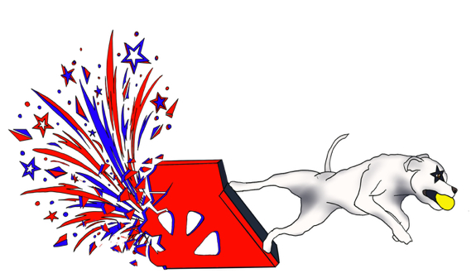

Welcome to
Let Freedom Race!
XXII
July 17-19, 2026

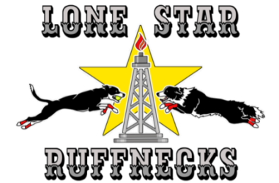

Thank you all for joining us this year for Let Freedom Race XXII! A packet with wristbands for unlimited entry to the show has been sent to your club contact. Please see one of us at the score table if you need more or have extras.

CRATING: Crating will be open for equipment dropoff on Tuesday morning no earlier than 10 am. You will be able to drive in all day on Tuesday, but please be aware of other clubs' equipment that may already be in place. No long term parking in the building. Once you've dropped off your equipment, please move your vehicle out to the parking lot. There won’t be AC on Tuesday or Wednesday so please don’t plan to leave your dogs in the crating area. Drive-in will be allowed Wednesday morning until 11 am. Again, please be aware of other clubs' setups. And no long term parking in the building. Please move your vehicle out to the parking lot as soon as possible. Building will open at 7:30 am on Friday and 6:30 am on Saturday and Sunday. We are assigning crating space for each team. A special note to those who want to set up crating along the air wall: you may not be closer than a foot from the wall so please make your plans accordingly. The crating map has been uploaded to Canine Sports Hub and posted at https://nafaregion5.com/region-5-upcoming-tournaments/

HOSPITALITY: You are welcome to enjoy a very limited amount of hospitality in your team area but nothing extreme is allowed. The contractor for this facility will be looking for loss of revenue and you will be asked to close up any large displays of food and drinks. Excellent food is available within the NRG Center for the weekend.

ELECTRICITY: There will be centrally located outlets available for the crating area. Please be prepared to run an extension cord to your particular area. Heavy use will trip a breaker and cut off power to the crating area, so please be reasonable about power consumption. Since we have many scooters every year, please plan to rotate their charging so that all scooters are not on the power system at the same time. Your help in this matter will allow everyone to have power throughout the crating area.

PARKING: Enter the Park through Gate 12 on North Stadium Dr, turn left and take the last right into our usual lot on the east side of NRG Center, marked Orange 6. We are told you should be able to get to flyball parking unhindered through Gate 12. If you enter through Gate 10 from Kirby Dr turn left as soon as you can and drive north to the back of the lot (Red 4). Turn right, take the north road past Gate 12 and the Tan Lot, and take the last right into parking in Orange 6.

Parking is $28 per day (No re-entry) and passes can be purchased in advance at
https://www.justpark.com/us/event-parking/nrg-park/#nrg-center-parking
before the Dog Show or purchased at the gate. No cash. Parking is free on Wednesday - tell the gate attendant you’re here for the Dog Show. Weekend in/out passes can be purchased at a booth in Hall D in the NRG Center and online on the Exhibitors page at houstondogshows.com. You have to open an account to buy online.

RACE NUMBERS: We are running only one ring this year. As always we will provide race numbers that are visible in the crating area and we will be using Canine Sports Hub. People with mobile devices can use the app to keep track of racing.

RACING: We’re very excited to have you racing with us at LFRXXII! Friday will be a light day with breaks, 2-minute warmups all day and 10-minute green dog spots. The weekend tournament will be different. We’ll be racing long days starting at 7:30 am Saturday and Sunday. There will be no mat time during racing on the weekend! There are 59 races on Saturday and 53 on Sunday. We’ll start with 2-minute warmups for your first race of the day and go to 1-minute warmups after that. Since we’re doing a lot of racing, please be efficient in getting in and out of the ring and please let the judge know if you’re ready before the warm-up time is over. We are using 30” wide jumps and will have both line and box judges. Judging assignments will be included in the schedules. Please let us know if you have conflicts or need help filling the chairs.

WARMUPS: To help keep events moving along as teams scramble for their warmup paraphernalia, LSR will have two extra jump boards available for anyone to use if necessary. The jump boards are 8"/6" and 4' long. There were also be two 25-lb weights available per ring.

DOG BREAK AREAS: There will be access to the grass outside which will be monitored for cleanliness so please pick up after your dogs. An indoor cedar shavings area will be provided at the side of the racing lanes for those that do not choose to walk to the grass.

TIMELINE:
Tuesday:
Crating area is open after 10 am for drive in and drop off of equipment. You will be able to drive in all day on Tuesday, but please be aware of clubs' equipment that may already be in place. Also, please no long term parking in the building. Once you've unloaded, please move your vehicle out to the parking lot. No AC in the building on Tuesday so please don’t plan to leave your dogs in the crating area.

Wednesday:
You may drive into the building but your vehicle must be out by 11 am. Again, please be aware of other clubs' setups. And NO long term parking in the building. Please move your vehicle out to the parking lot as soon as possible. No AC in the building on Wednesday so please don’t plan to leave your dogs in the crating area.

Thursday:
Walk up access only. Please have your wristbands for entry.

Friday:
- Building opens: 7:30 am
- Check In via CSH will close at 8:35 am. Please check with Terry at the Table if you have questions.
- Measuring: 8:00 am
- PreRace Meeting for everyone: 8:40 am
- Racing: 9:00 am (2-minute warmups all day)
- 21 mat time spots during breaks, 10 minutes each
- 1-hour lunch break (6 of the mat times spots) scheduled at 12:00
- Awards after racing ends

Saturday:
- Building opens: 6:30 am
- Check In via CSH will close at 7:15 am. Please check with Terry at the Table if you have questions.
- Measuring: 7:00 am
- PreRace Meeting: 7:15 am
- Racing: 7:30 am (2-minute warmups first race, 1-minute warmups after that)

Sunday:
- Building opens: 6:30 am
- Racing: 7:30 am (2-minute warmups first race, 1-minute warmups after that)
- Awards after racing ends

SCORING:
Tournament points:
The winner of each heat will receive one (1) tournament point, and the winner of the majority of heats in a race will be awarded an additional two (2) bonus points. Heats ending in a tie will result in each team receiving one (1) tournament point.

Division Tie Breakers:
(1) Results of head to head competition at the heat level
(2) Fastest legal time in head to head competition
(3) Fastest legal time of the day

TOURNAMENT T-SHIRTS: T-Shirts with the LFRXXII logo are available to order online at let-freedom-race-xxii.myspreadshop.com. Please let Terry know if you don’t see a product that you want.

LODGING: HWSDS list of hotels and RV parks near NRG Center (some don’t take dogs): https://1bdba612-2a56-431f-aee0-48d32fe2065b.usrfiles.com/ugd/1bdba6_66366a488e8844598755bc6bf7d240ee.pdf

PARKING MAP: (https://www.houstondogshows.com/venue) below
Closest parking for us is the Orange Lot area marked 6 at the blue arrow.

